***Business Analytics, 2e, GE* (Evans)**

**Chapter 1 Introduction to Business Analytics**

1) Descriptive analytics:

A) can predict risk and find relationships in data not readily apparent with traditional analyses.

B) helps companies classify their customers into segments to develop specific marketing campaigns.

C) helps detect hidden patterns in large quantities of data to group data into sets to predict behavior.

D) can use mathematical techniques with optimization to make decisions that take into account the uncertainty in the data.

Answer: B

Diff: 1

Blooms: Remember

Topic: Scope of Business Analytics

LO1: Explain and provide examples of descriptive, predictive, and prescriptive analytics.

LO2: Compare and contrast tools for presenting and organizing data

2) A manager at Gampco Inc. wishes to know the company's revenue and profit in its previous quarter. Which of the following business analytics will help the manager?

A) prescriptive analytics

B) normative analytics

C) descriptive analytics

D) predictive analytics

Answer: C

Diff: 1

Blooms: Apply

AACSB: Analytic Skills

Topic: Scope of Business Analytics

LO1: Explain and provide examples of descriptive, predictive, and prescriptive analytics.

LO2: Describe the major tools and criteria for decision making.

3) Predictive analytics:

A) summarizes data into meaningful charts and reports that can be standardized or customized.

B) identifies the best alternatives to minimize or maximize an objective.

C) uses data to determine a course of action to be executed in a given situation.

D) detects patterns in historical data and extrapolates them forward in time.

Answer: D

Diff: 2

Blooms: Remember

Topic: Scope of Business Analytics

LO1: Explain and provide examples of descriptive, predictive, and prescriptive analytics.

LO2: Compare and contrast tools for presenting and organizing data

4) A trader who wants to predict short-term movements in stock prices is likely to use ________ analytics.

A) predictive

B) descriptive

C) normative

D) prescriptive

Answer: A

Diff: 1

Blooms: Apply

AACSB: Analytic Skills

Topic: Scope of Business Analytics

LO1: Explain and provide examples of descriptive, predictive, and prescriptive analytics.

LO2: Describe the major tools and criteria for decision making.

5) Which of the following questions will prescriptive analytics help a company address?

A) How many and what types of complaints did they resolve?

B) What is the best way of shipping goods from their factories to minimize costs?

C) What do they expect to pay for fuel over the next several months?

D) What will happen if demand falls by 10% or if supplier prices go up 5%?

Answer: B

Diff: 2

Blooms: Understand

AACSB: Analytic Skills

Topic: Scope of Business Analytics

LO1: Explain and provide examples of descriptive, predictive, and prescriptive analytics.

LO2: Describe the major tools and criteria for decision making.

6) What is a database?

A) a structured collection of related files and data

B) simply a collection of data

C) a data file holding a single file

D) flat files used to store data

Answer: A

Diff: 1

Blooms: Remember

Topic: Data for Business Analytics

LO1: Explain the difference between a data set and a database.

LO2: Explain how data are acquired and distinguish among different types of data and levels of measurement

7) In a database, information is stored and maintained in ________.

A) fields

B) measurements

C) entities

D) attributes

Answer: C

Diff: 1

Blooms: Remember

Topic: Data for Business Analytics

LO1: Explain the difference between a data set and a database.

LO2: Explain how data are acquired and distinguish among different types of data and levels of measurement

8) Which of the following is an example of a measure of continuous metrics?

A) four errors revealed in an invoice

B) a delivery delayed by seven days

C) weight and volume of a sheet of steel

D) three incomplete orders on a day

Answer: C

Diff: 2

Blooms: Understand

Topic: Data for Business Analytics

LO1: Explain the difference between a discrete metric and continuous metric, and provide examples of each.

LO2: Explain how data are acquired and distinguish among different types of data and levels of measurement

9) Nominal data:

A) are ranked according to some relationship to one another.

B) have constant differences between observations.

C) are continuous and have a natural zero.

D) are sorted into categories according to specified characteristics.

Answer: D

Diff: 1

Blooms: Remember

Topic: Data for Business Analytics

LO1: Describe the four groups of data classification, categorical, ordinal, interval, and ratio, and provide examples of each.

LO2: Explain how data are acquired and distinguish among different types of data and levels of measurement

10) Which of the following is a disadvantage of ordinal data?

A) They bear no relationship to one another.

B) They have no fixed units of measurement.

C) They have no natural zero.

D) They are not comparable with each other.

Answer: B

Diff: 2

Blooms: Understand

Topic: Data for Business Analytics

LO1: Describe the four groups of data classification, categorical, ordinal, interval, and ratio, and provide examples of each.

LO2: Explain how data are acquired and distinguish among different types of data and levels of measurement

11) Which of the following allow meaningful comparison of ranges, averages and other statistics?

A) interval data

B) categorical data

C) ratio data

D) ordinal data

Answer: A

Diff: 1

Blooms: Remember

Topic: Data for Business Analytics

LO1: Describe the four groups of data classification, categorical, ordinal, interval, and ratio, and provide examples of each.

LO2: Explain how data are acquired and distinguish among different types of data and levels of measurement

12) Following are the components of a data set containing purchase details of a shoe manufacturing company. Identify the ratio data.

A) Item Number

B) Rank of suppliers

C) Item cost

D) Arrival Date

Answer: C

Diff: 2

Blooms: Apply

Topic: Data for Business Analytics

LO1: Describe the four groups of data classification, categorical, ordinal, interval, and ratio, and provide examples of each.

LO2: Explain how data are acquired and distinguish among different types of data and levels of measurement

13) When data are classified by the type of measurement scale, which is the strongest form of measurement?

A) nominal

B) interval

C) ordinal

D) ratio

Answer: D

Diff: 1

Blooms: Remember

Topic: Data for Business Analytics

LO1: Describe the four groups of data classification, categorical, ordinal, interval, and ratio, and provide examples of each.

LO2: Explain how data are acquired and distinguish among different types of data and levels of measurement

14) The demand for coffee beans over a period of three months has been represented in the form of an L-shaped curve. Which form of model was used here?

A) mathematical model

B) visual model

C) kinesthetic (tactile) model

D) verbal model

Answer: B

Diff: 1

Blooms: Apply

AACSB: Analytic Skills

Topic: Decision Models

LO1: Explain the concept of a model and various ways a model can be characterized.

LO2: Compare and contrast tools for presenting and organizing data

15) Decision variables:

A) cannot be directly controlled by the decision maker.

B) are assumed to be constant.

C) are always uncertain.

D) can be selected at the discretion of the decision maker.

Answer: D

Diff: 2

Blooms: Understand

Topic: Decision Models

LO1: Define and list the elements of a decision model.

LO2: Describe the major tools and criteria for decision making.

16) Identify the uncontrollable variable from the following inputs of a decision model.

A) investment returns

B) machine capacities

C) staffing levels

D) intercity distances

Answer: A

Diff: 1

Blooms: Apply

Topic: Decision Models

LO1: Define and list the elements of a decision model.

LO2: Describe the major tools and criteria for decision making.

17) Which of the following inputs of a decision model is an example of data?

A) estimated consumer demand

B) inflation rates

C) costs

D) investment allocations

Answer: C

Diff: 1

Blooms: Remember

Topic: Data for Business Analytics

LO1: Define and list the elements of a decision model.

LO2: Describe the major tools and criteria for decision making.

18) Descriptive decision models:

A) aim to predict what will happen in the future.

B) describe relationships but do not tell a manager what to do.

C) help analyze the risks associated with various decisions.

D) do not facilitate evaluation of different decisions.

Answer: B

Diff: 2

Blooms: Understand

Topic: Decision Models

LO1: Explain the concept of a model and various ways a model can be characterized.

LO2: Describe the major tools and criteria for decision making.

19) The total cost of reaching consumers (C) depends upon the number of consumers (N), advertising costs (A), and transportation costs (T). The linear cost prediction model is represented as:

*C = c - nN + aA + tT*

where c, n, a, and t are constants and c estimates the total cost when the remaining variables are zero. Which of the following interpretations is true about this model?

A) Change in variables N, A, and T will cause n, a, and t to change.

B) As n decreases, c will increase.

C) When variables N, A, and T are zero, *C = c - n + a + t*.

D) Change in variables N, A, and T will not reflect any changes in c.

Answer: D

Diff: 3

Blooms: Apply

Topic: Decision Models

LO1: Use influence diagrams to build simple mathematical models.

LO2: Compare and contrast methods of summarizing and describing data

20) Which of the following is the mathematical model for deriving total cost of only manufacturing?

A) *TC = VC + (C × Q)*

B) *TC = F + (C × Q)*

C) *TC = F + C*

D) *TC = F + (V × Q)*

Answer: D

Diff: 2

Blooms: Apply

AACSB: Analytic Skills

Topic: Decision Models

LO1: Use influence diagrams to build simple mathematical models.

LO2: Describe the major tools and criteria for decision making.

21) Which of the following is the mathematical model for deriving total cost of only outsourcing?

A) *TC = Q x C*

B) *TC = F + (C x Q)*

C) *TC = (V + C) x Q*

D) *TC = (VC + F) x Q*

Answer: A

Diff: 2

Blooms: Apply

AACSB: Analytic Skills

Topic: Decision Models

LO1: Use influence diagrams to build simple mathematical models.

LO2: Describe the major tools and criteria for decision making.

22) Which of the following is the mathematical model for deriving the break-even volume?

A) *Q = (C - VC) + F*

B) *Q = F / (C -V)*

C) *Q = (V + C) / F*

D) *Q = F / (VC - C)*

Answer: B

Diff: 2

Blooms: Apply

AACSB: Analytic Skills

Topic: Decision Models

LO1: Use influence diagrams to build simple mathematical models.

LO2: Describe the major tools and criteria for decision making.

23) When will a company use a predictive decision model?

A) when it wishes to determine the best product pricing to maximize revenue

B) when it wishes to know how best to use advertising strategies to influence sales

C) when it wishes to know sales patterns to plan inventory levels

D) when it wishes to ensure that a specified level of customer service is achieved

Answer: C

Diff: 2

Blooms: Understand

AACSB: Analytic Skills

Topic: Decision Models

LO1: Use predictive models to compute model outputs.

LO2: Describe the major tools and criteria for decision making.

24) If D is demand, P is the unit price, and c and d are constants (where d > 0 is the price elasticity), which of the following is a nonlinear demand prediction model?

A) *D = d + (c × P)*

B) *D = (d × P)c*

C) *D = cd × P*

D) *D = cP-d*

Answer: D

Diff: 2

Blooms: Apply

AACSB: Analytic Skills

Topic: Decision Models

LO1: Use predictive models to compute model outputs.

LO2: Describe the major tools and criteria for decision making.

25) Which decision model incorporates the uncertainty element?

A) predictive

B) normative

C) prescriptive

D) descriptive

Answer: A

Diff: 1

Blooms: Remember

Topic: Decision Models

LO1: Use predictive models to compute model outputs.

LO2: Describe the major tools and criteria for decision making.

Use the chart below to answer the following two questions:

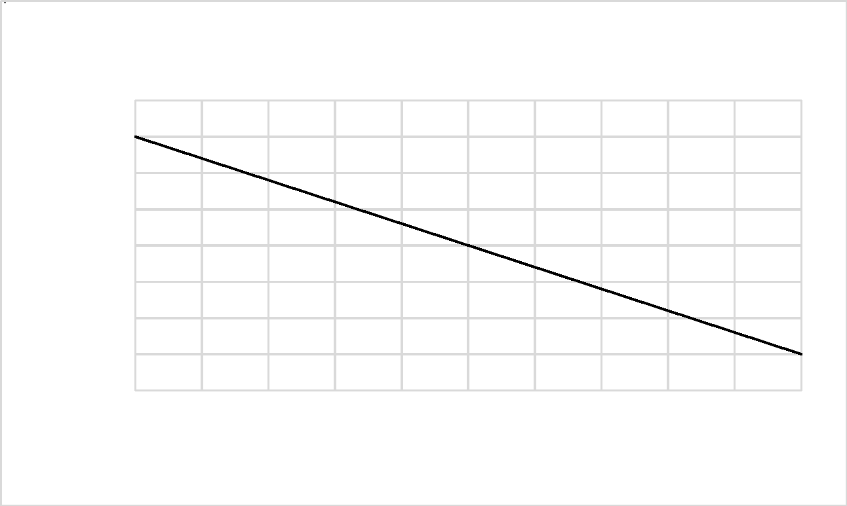

26) What is the slope of the sales function *D = a - bP*?

A) 4

B) 9

C) 12

D) 17

Answer: C

Diff: 3

Blooms: Apply

Topic: Decision Models

LO1: Use influence diagrams to build simple mathematical models.

LO2: Describe the major tools and criteria for decision making.

27) How many gallons will be sold if the price is increased to $4.75?

A) 833.26

B) 843

C) 798.72

D) 818

Answer: B

Diff: 3

Blooms: Apply

AACSB: Analytic Skills

Topic: Decision Models

LO1: Use predictive models to compute model outputs.

LO2: Describe the major tools and criteria for decision making.

28) Prescriptive decision models help:

A) make predictions of how demand is influenced by price.

B) make trade-offs between greater rewards and risks of potential losses.

C) decision makers identify the best solution to decision problems.

D) describe relationships and influence of various elements in the model.

Answer: C

Diff: 1

Blooms: Remember

Topic: Decision Models

LO1: Define the terms optimization, objective function, and optimal solution.

LO2: Describe the major tools and criteria for decision making.

29) The manager at Soul Walk Inc., a shoe manufacturing company, wants to set a new price (P) for a shoe model to maximize total profit. The demand (D) as a function of price is represented as:

*D = 1,500 - 2.5P*

The total cost (C) as a function of demand is represented as:

*C = 3,200 + 3.5D*

Which of the following is a model for total profit as a function of price?

A) *(1,508.75× price) - (2.5 × price2) - 8,450*

B) *(3.5 × price2) + 3,200 - (1925.50 × price)*

C) *(1,250 × price) + (5 × price2) - 8,320*

D) *[4521 + (4.5 × price)] × price - 9684.25*

Answer: A

Diff: 3

Blooms: Apply

Topic: Decision Models

LO1: Define the terms optimization, objective function, and optimal solution.

LO2: Describe the major tools and criteria for decision making.

30) Which decision model incorporates the process of optimization?

A) predictive

B) prescriptive

C) descriptive

D) normative

Answer: B

Diff: 1

Blooms: Remember

Topic: Decision Models

LO1: Define the terms optimization, objective function, and optimal solution.

LO2: Describe the major tools and criteria for decision making.

31) Which of the following is the first phase in problem solving?

A) defining the problem

B) analyzing the problem

C) recognizing the problem

D) structuring the problem

Answer: C

Diff: 1

Blooms: Remember

Topic: Problem Solving and Decision Making

LO1: List and explain the steps in the problem-solving process.

LO2: Describe the major tools and criteria for decision making.

32) Middle managers in operations:

A) develop staffing plans.

B) determine product mix.

C) develop advertising plans.

D) make pricing decisions.

Answer: A

Diff: 1

Blooms: Remember

Topic: Problem Solving and Decision Making

LO1: List and explain the steps in the problem-solving process.

LO2: Describe the major tools and criteria for decision making.

33) The product mix is determined by the:

A) accounting staff.

B) middle managers.

C) finance managers.

D) top managers.

Answer: D

Diff: 1

Blooms: Remember

Topic: Problem Solving and Decision Making

LO1: List and explain the steps in the problem-solving process.

LO2: Describe the major tools and criteria for decision making.

34) During which phase in problem solving is a formal model often developed?

A) analyzing the problem

B) structuring the problem

C) defining the problem

D) implementing the solution

Answer: B

Diff: 1

Blooms: Remember

Topic: Problem Solving and Decision Making

LO1: List and explain the steps in the problem-solving process.

LO2: Describe the major tools and criteria for decision making.

35) Which of the following is true about problem solving?

A) Recognizing problems involves stating goals and objectives.

B) Analyzing the problem involves characterizing the possible decisions.

C) Decision making involves translating the results of the model in the organization.

D) Structuring the problem involves identifying constraints.

Answer: D

Diff: 2

Blooms: Understand

Topic: Problem Solving and Decision Making

LO1: List and explain the steps in the problem-solving process.

LO2: Describe the major tools and criteria for decision making.

36) To meet consumer demand, Nib 'N' Ink must produce 800 gel-ink refills. Should the company produce them in-house or outsource them from the supplier? (Hint: Use the mathematical descriptive model).

Answer: *Total Cost of Manufacturing (TC) = Fixed Cost (F) + Variable Cost (VC)*

*VC = Unit Variable Cost (V) × Quantity Produced (Q)*

*TC = F + VQ* = 2,400 + 3 x 800 = 4,800

Total Cost of Outsourcing (TC) = Unit Cost (C) x Quantity Outsourced (Q)

*TC = CQ* = 5 × 800 = 4,000

The gel-ink refills must be outsourced with the total cost of manufacturing the refills in-house being greater than outsourcing them.

Diff: 3

Blooms: Apply

AACSB: Analytic Skills

Topic: Decision Models

LO1: Use influence diagrams to build simple mathematical models.

LO2: Describe the major tools and criteria for decision making.

37) Find the range of volumes at which it is more economical for Nib 'N' Ink to produce the refills in-house or outsource them. (Hint: Use the break-even decision model).

Answer: Break-even volume can be arrived at by setting TC (manufacturing) = TC (outsourcing) and solving for Q.

*F + V × Q = C × Q*

*Q = F / (C - V)* = 2,400 / (5 - 3) = 1,200

Thus, if the anticipated production volume is greater than 1,200, it is more economical to manufacture the refills; if it is less than 1,200, then they should be outsourced.

Diff: 3

Blooms: Apply

AACSB: Analytic Skills

Topic: Decision Models

LO1: Use influence diagrams to build simple mathematical models.

LO2: Describe the major tools and criteria for decision making.

38) Profit is computed as the difference between total revenue from sales and total cost of production. Revenue depends on the market share captured by a company and the size of the target market. Various marketing decisions taken by managers are reflected upon the market share. The decisions also have an impact on marketing costs which in turn will affect the total cost of production. Construct an influence diagram that relates these variables.

Answer: 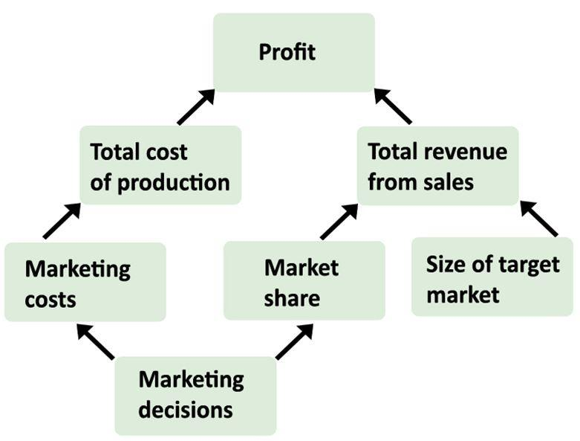

Diff: 3

Blooms: Apply

AACSB: Analytic Skills

Topic: Decision Models

LO1: Define and provide an example of an influence diagram.

LO2: Describe the major tools and criteria for decision making.

39) Develop a linear model relating the demand for Goody Woods' units to the price.

Answer: Economic theory tells us that demand for a product is negatively related to its price.

The linear model to predict demand as a function of price is:

*D = a - bP*

where D is the quantity demanded, P is the unit price, a is a constant that estimates the demand when the price is zero, and b is the slope of the demand function.

Substituting the values given in the data:

*1,540 = a - (b × 240)*

*1,220 = a - (b × 320)*

By solving the two equations, values of a and b can be found.

a = 2,500, which indicates the demand for wood units when price is zero,

b = 4, which is the slope of the demand function.

Substituting values of a and b in the linear demand prediction model:

*D = 2,500 - 4P*

Diff: 3

Blooms: Apply

AACSB: Analytic Skills

Topic: Decision Models

LO1: Use predictive models to compute model outputs.

LO2: Describe the major tools and criteria for decision making.

40) Develop a prescriptive model that will help Goody Woods identify the price that maximizes the total revenue.

Answer: Having found out the model for demand as a function of price, sales (S) can be expressed as:

*S = 2,500 - 4P*

*Revenue (R) = Sales x Price = (2,500 - 4P) × P = 2,500P - 4P2*

Thus, Goody Woods Inc. can identify the price that maximizes the total revenue using:

*R = 2,500P - 4P2*

Diff: 3

Blooms: Apply

AACSB: Analytic Skills

Topic: Decision Models

LO1: Define the terms optimization, objective function, and optimal solution.

LO2: Describe the major tools and criteria for decision making.

41) Decision support systems evolved from efforts to improve military operations prior to and during World War II.

Answer: FALSE

Diff: 1

Blooms: Remember

Topic: Evolution of Business Analytics

LO1: Summarize the evolution of business analytics and explain the concepts of business intelligence, operations research and management science, and decision support systems.

LO2: Identify different business uses for statistics and the major statistical tools businesses use

42) In a database file, which is organized in a two-dimensional table, the rows represent records of related data elements.

Answer: TRUE

Diff: 1

Blooms: Remember

Topic: Data for Business Analytics

LO1: Explain the difference between a data set and a database.

LO2: Compare and contrast tools for presenting and organizing data

43) Measure is the act of obtaining data associated with a metric. Measurements are the numerical values associated with a metric.

Answer: FALSE

Diff: 1

Blooms: Remember

Topic: Data for Business Analytics

LO1: Define a metric and explain the concepts of measurement and measures.

LO2: Explain how data are acquired and distinguish among different types of data and levels of measurement

44) A deterministic model is one in which all model input information is either known or assumed to be known with certainty.

Answer: TRUE

Diff: 1

Blooms: Remember

Topic: Decision Models

LO1: Explain the difference between a deterministic and stochastic decision model.

LO2: Describe the major tools and criteria for decision making.

45) The complexity of a problem increases when the problem belongs to an individual rather than a group.

Answer: FALSE

Diff: 1

Blooms: Remember

Topic: Problem Solving and Decision Making

LO1: List and explain the steps in the problem-solving process.

LO2: Describe the major tools and criteria for decision making.

46) A goal of Korel&Marke, a dot-com company, is to gain strategic advantage over its rival firms. How can Korel&Marke use analytics and exploit social media to accomplish this goal?

Answer: Analytics is helping businesses learn from social media and exploit social media data for strategic advantage. Using analytics, Korel&Marke can integrate social media data with traditional data sources such as customer surveys, focus groups, and sales data. It can also understand trends and customer perceptions of its products; and create informative reports to assist its marketing managers and product designers.

Diff: 2

Blooms: Understand

Topic: What is Business Analytics?

LO1: State some typical examples of business applications in which analytics would be beneficial.

LO2: Identify different business uses for statistics and the major statistical tools businesses use

47) What are the three components of decision support systems (DSS)?

Answer: DSSs include three components:

• Data management - The data management component includes databases for storing data and allows the user to input, retrieve, update, and manipulate data.

• Model management - The model management component consists of various statistical tools and management science models and allows the user to easily build, manipulate, analyze, and solve models.

• Communication system - The communication system component provides the interface necessary for the user to interact with the data and model management components.

Diff: 2

Blooms: Remember

Topic: Evolution of Business Analytics

LO1: Summarize the evolution of business analytics and explain the concepts of business intelligence, operations research and management science, and decision support systems.

LO2: Describe the major tools and criteria for decision making.

48) Explain how data are used by accountants, economists, and operations managers.

Answer: Following are the ways data are used:

• Accountants conduct audits to determine whether figures reported on a firm's balance sheet fairly represent the actual data by examining samples (that is, subsets) of accounting data, such as accounts receivable.

• Economists use data to help companies understand and predict population trends, interest rates, industry performance, consumer spending, and international trade.

• Operations managers use data on production performance, manufacturing quality, delivery times, order accuracy, supplier performance, productivity, costs, and environmental compliance to manage their operations.

Diff: 2

Blooms: Remember

Topic: Data for Business Analytics

LO1: State examples of how data are used in business.

LO2: Identify different business uses for statistics and the major statistical tools businesses use

49) Data used in business analytics need to be reliable and valid. Explain.

Answer: Sample data do not always reflect reality. People do not always behave the same when observed, nor do they always act as they say they act. Poor data can result in poor decisions. Hence, care must be taken when working with data, and every effort should be made to ensure that data are sufficiently accurate.

Diff: 2

Blooms: Remember

Topic: Data for Business Analytics

LO1: State examples of how data are used in business.

LO2: Describe the major tools and criteria for decision making.

50) Why do predictive decision models incorporate uncertainty?

Answer: The future is always uncertain. Uncertainty is imperfect knowledge of what will happen; risk is associated with the consequences of what actually happens. Even though uncertainty may exist, there may be no risk. However, risk is an outcome of uncertainty, though not always. Thus, many predictive models incorporate uncertainty and help decision makers analyze the risks associated with their decisions.

Diff: 2

Blooms: Understand

Topic: Decision Models

LO1: Explain the difference between uncertainty and risk.

LO2: Describe the major tools and criteria for decision making.